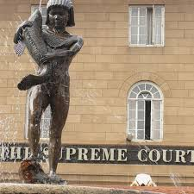
NECKED BOY OF JUSTICE STACHUE

